## Trip Calculator Design Outline

### Constants

1. The unit price for food is set to 147
2. The unit price for gas is set to 169

### User Inputs

1. The number of people going on the road trip
2. The number of days they will do the road trip

### Program Output

1. The total cost of the food and gas for the number of people and days spent
2. The total cost of the trip
3. The total cost per person for the whole trip
4. Type error if the input is not a number/integer

### Steps on how to achieve this

1. Prompt the user for the number of people going on the trip
2. Prompt the user for the total number of days they will spend on the trip
3. Given the number of people, calculate the total expenditure for food for each person for the total number of days and the total expenditure for gas for all the days
4. Sum the food and gas cost to get the total expenditure of the trip
5. Divide the total sum of the trip by the number of people to get the cost per person for the trip
6. Print the computed cost for the user.

### 

### Test Cases

| **Test Case** | **Input** | **Total Cost of Food** | **Total Cost of Gas** | **Total Trip Cost** | **Cost Per Person** |
| --- | --- | --- | --- | --- | --- |
| 5 days and 5 people | People: 5 Days: 5 | $3675 | $845 | $4520 | $904 |
| 3 People and 6 Days | People: 3 Days: 6 | $2646 | $1014 | $3660 | $1220 |
| 10 People and 2 Days | People: 10 Days: 2 | $2940 | $338 | $3278 | $327.8 |
| 1 Person 1 Day | People: 1  Days: 1 | $147 | $169 | $316 | $316 |

### Screenshots

#### Test Case 1: 5 People 5 Days

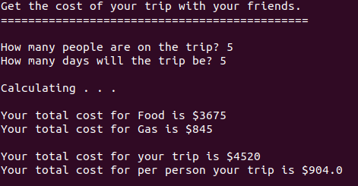

#### Test Case 2: 3 People and 6 Days

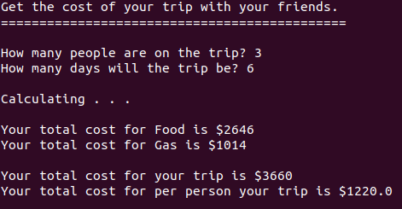

#### Test Case 3: 10 People 2 Days

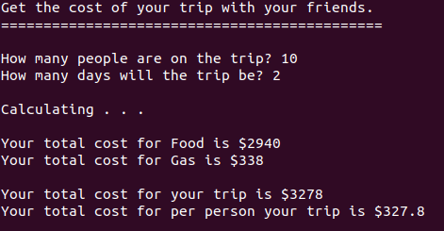

#### Test Case 4: 1 Person 1 Day

